**ITC LAB REPORT  
19L-1316**

**HAFIZ AHMAD**

**EE 2A**

**Experiment No.08**

**C++ Functions**

**OBJECTIVE**:

• To understand how to use pre-defined functions

• To understand how to define your own functions

• To get familiar with value returning functions

Functions allow to structure programs in segments of code to perform individual tasks.

In C++, a function is a group of statements that is given a name, and which can be called from some point of the program. The most common syntax to define a function is:

type name ( parameter1, parameter2, ...) { statements }

Where:

- ‘type’ is the type of the value returned by the function.

- ‘name’ is the identifier by which the function can be called.

- ‘parameters’ (as many as needed): Each parameter consists of a type followed by an identifier, with each parameter being separated from the next by a comma. Each parameter looks very much like a regular variable declaration (for example: int x), and in fact acts within the function as a regular variable which is local to the function. The purpose of parameters is to allow passing arguments to the function from the location where it is called from.

- ‘statements’ is the function's body. It is a block of statements surrounded by braces { } that specify what the function actually does.

Let's have a look at an example:

// function example

#include <iostream> usingnamespace std;

int addition (int a, int b)

{

int r;

r=a+b; return r;

}

int main ()

{

int z;

z = addition (5,3);

cout <<"The result is "<< z;

}

This program is divided in two functions: addition and main. Remember that no matter the order in which they are defined, a C++ program always starts by calling main. In fact, main is the only function called automatically, and the code in any other function is only executed if its function is called from main (directly or indirectly).

**Exercise –1 (5 points)**

Write a program that will find the area and volume of sphere.

Data type for all variable should be double

double area (doubleradius)**:** function that will take radius as input and return the area. double volume (doubleradius): takes radius as input argument and return the volume of sphere.

𝐴𝑟𝑒𝑎 = 4 𝜋 𝑟2

4

𝑉𝑜𝑙𝑢𝑚𝑒 = 𝜋 𝑟3

3

Write a main function that will take radius from the user and display the area and volume, don’t

display the area and volume in the function

#include <iostream>

#include <cmath>

using namespace std;

double pi=3.1416;

double area(double radius){

double a;

a=4*pi*pow(radius,2);

return a;

}

double volume(double radius)

{

double v;

v=(4/3)*pi*pow(radius,3);

return v;

}

int main()

{

int r;

cout<<"enter the radius"<<endl;

cin>>r;

cout<<"area="<<area(r)<<endl;

cout<<"volume"<<volume(r)<<endl;

return 0;

}

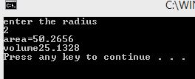

**Exercise –2 (5 points)**

Write a void function **calculateRoots( )** that takes three input parameters ‘a’, ‘b’, ‘c’; computes two roots and display them on console. You may use pre-defined functions for taking square and square root. Following expression calculates roots of a quadratic equation.

−𝑏 ± √𝑏2 − 4𝑎𝑐 2𝑎

Write a main( ) to test your function. Take values of ‘a’, ‘b’, ‘c’ from user. This program solve quadratic equation only for this condition.

𝑏2 − 4𝑎𝑐 > 0

#include <iostream>

#include <cmath>

using namespace std;

void function(double a,double b,double c){

double e1,e2;

e1=(-b+sqrt(pow(b,2)-4*a*c))/(2*a);

e2=(-b-sqrt(pow(b,2)-4*a*c))/(2*a);

cout<<"root 1="<<e1<<endl;

cout<<"root 2="<<e2<<endl;

}

int main()

{

double a,b,c;

cout<<"enter the number"<<endl;

cin>>a;

cin>>b;

cin>>c;

if((pow(b,2)-4*a*c)>0){

function(a,b,c);

}

else

cout<<"no correct number enter"<<endl;

}

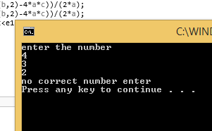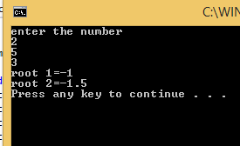

**Exercise –5 (10 points)**

The sum of the squares of the first ten natural numbers is, 12 + 22 + ... + 102 = 385.The square of the sum of the first ten natural numbers is, (1 + 2 + ... + 10)2 = 552 = 3025.Hence the difference between the square of the sum of the first ten natural numbers and the sum of the squares of first ten natural numbers is 3025 − 385 = 2640.

Find the difference between the square of the sum of the first ten natural numbers and the sum of the squares of first ten natural numbers

#include <iostream>

#include <cmath>

using namespace std;

int square_sum()

{

int a,squaresum=0;

for(int i=1;i<=10;i++){

a=pow(i,2);

squaresum=squaresum+a;

}

return squaresum;

}

int sum_square()

{

int sumsquare,b=0;

for(int i=1;i<=10;i++){

b=b+i;

}

sumsquare=pow(b,2);

return sumsquare;

}

int main(){

cout<<"difference b/w sum of square number and square of sum is "<<sum_square()-square_sum()<<endl;

return 0;

}

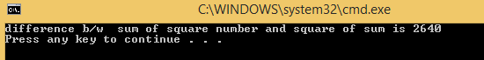

**Exercise –3 (5 points)**

Write a function that takes a **four-digit number** as input in a single variable from user and returns the sum of its four digits. If user enters 2345, then output of program should be: 14

The input from user should be taken in main and then passed to the function as its parameter. The output from function should be displayed on console in main. 

Prototype should be void four_digit_number(int number) 

#include <iostream>

#include <cmath>

using namespace std;

void four_digit_number(int x){

int a=0,b=0;

while(x!=0){

a=x%10;

b=b+a;

x=x/10;

}

cout<<"sum="<<b<<endl;}

int main(){

int a;

cout<<"enter the 4 digit number"<<endl;

cin>>a;

four_digit_number(a);

}

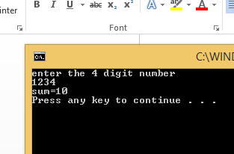

**Exercise –4 (10 points)**

Write a function that determines the median of three input numbers. The median is the middle number when the three numbers are arranged in order. However, the user can input the values in any order, so your program must determine which value is between the other two. For example, if the user enters:

41.52; 27.18; 96.03

Then the program would output:

The median of 41.52, 27.18 and 96.03 is 41.52

#include <iostream>

#include <cmath>

using namespace std;

double m(double a,double b,double c)

{

if(a<b&&a>c||a>b&&a<c){

return a;

}else if(b<a&&b>c||b<c&&b>a){

return b;}

else

return c;

}

int main()

{ double a1,a2,a3;

cout<<"enter the values"<<endl;

cin>>a1;

cin>>a2;

cin>>a3;

m(a1,a2,a3);

cout<<"median is"<<a1<<" "<<a2<<" "<<a3<<m(a1,a2,a3)<<endl;

}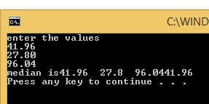

**Conclusion:**

In this lab we learn how we use function and understand pre-defined function and user defined function.

POST LAB:

Write a program that takes as input five numbers and find the mean (average) and standard deviation of the numbers.

**Mean Function:** write a function that takes 5 input arguments and return the means. 

**Standard Deviation Function:** Write a function that will return the standard deviation. 

If the numbers are x1, x2, x3, x4, and x5, then mean “x” and standard deviation “s” is given as:

𝑠=√(𝑥1−𝑥)2+(𝑥2−𝑥)2+(𝑥3−𝑥)2+(𝑥4−𝑥)2+(𝑥5−𝑥)2/5

𝑥 = 𝑥1 + 𝑥2 + 𝑥3 + 𝑥4 + 𝑥5/ 5

#include <iostream>

#include <cmath>

using namespace std;

int mean(int x1,int x2,int x3,int x4,int x5)

{

double x;

x=(x1+x2+x3+x4+x5)/5;

cout<<"mean="<<x<<endl;

return x;

}

int main()

{

int a,b,c,d,e;

cout<<"enter the five values"<<endl;

cin>>a;

cin>>b;

cin>>c;

cin>>d;

cin>>e;

double s,m;

m=mean(a,b,c,d,e);

s=sqrt((pow(a-m,2)+pow(b-m,2)+pow(c-m,2)+pow(d-m,2)+pow(e-m,2))/5);

cout<<"standard deviation="<<s<<endl;

return 0;

}

